
PB1/PHAK/1223/A 05-DEC-2023
PRE BOARD EXAMINATION - I (2023-24)
Subject: PHYSICS (MARKING SCHEME)  Grade: XII |  | Max. Marks: 70  Time: 3Hrs
 | SECTION- A
1. | d) q/6ε₀ |  |  |  | 1
2. | A) 10V |  |  |  | 1
3. | - 2V, 0.4 Ω |  |  |  | 1
4. | B) Dipole B |  |  |  | 1
5 | a) copper, aluminium, iron |  |  |  | 1
6. | A) IA |  |  |  | 1
7. | d) C is doubled and V remains unchanged |  |  |  | 1
8 | B) B is air cored , A is iron cored. |  |  |  | 1
9. | - deviates the ray through 90⁰ |  |  |  | 1
10. | B) Spherical wavefront |  |  |  | 1
11. | c) 2 I₀ |  |  |  | 1
12. | a) Second line of Balmer series |  |  |  | 1
For Questions 13 to 16, two statements are given –one labelled Assertion (A) and other labelled Reason (R). Select the correct answer to these questions from the options as given below.
- If both Assertion and Reason are true and Reason is correct explanation of Assertion.
- If both Assertion and Reason are true but Reason is not the correct explanation of Assertion.
- If Assertion is true but Reason is false.
- If both Assertion and Reason are false.

13. | Assertion(A): No work is done in moving a test charge from one point to another over an equipotential surface.  Reason(R): Electric field is always normal to the equipotential surface at every point
 | B) If both Assertion and Reason are true but Reason is not the correct explanation of Assertion. |  |  |  | 1
14. | Assertion(A):When two coils are wound on each other, the mutual induction between coil is maximum.  Reason(R): Mutual induction doesn’t depends on the orientation of the coils
 | - If Assertion is true but Reason is false |  |  |  | 1
15. | Assertion(A):A variable capacitor is connected in series with a bulb through AC source if the capacitance of variable capacitor is decrease the brightness of bulb is reduced Reason -- Reason(R):The reactance of capacitor increase if capacitance is reduced
 | - If both Assertion and Reason are true and Reason is correct explanation of Assertion |  |  |  | 1
16. | Assertion(A): No interference pattern is detected when two coherent sources are infinitely close to each other.  Reason(R): The fringe width is inversely proportional to the distance between the two slits
 | - If both Assertion and Reason are true and Reason is correct explanation of Assertion |  |  |  | 1
 | SECTION- B
17. | Formula (1)  doubled (1/2)  b) halved (1/2) |  |  |  | 2
 | OR
Equation(1)
9V(1)
18. | State Huygen’s principle.(1/2)  diagram,(1/2)  proof(1mk). |  |  |  | 2
19. | proof |  |  |  | 2
20. | a) the densities 1:1 (1/2) formula( ½)  b) the radii 1:3 (1/2) formula(1/2) |  |  |  | 2
21. | a) Cx=Cy=Cz (1mk)  b) Rx<Ry<Rz (1 mk) |  |  |  | 2
 | SECTION -C
22. | - C’=5C (1/2), formula(1/2)  - Q’=5Q(1/2) formula(1/2)  - U’=5U(1/2) formula(1/2) |  |  |  | 3
23. | a) Name the device X -resistor and Y-capacitor(1/2,1/2).  b) .R=440ohm, Xc=440ohm (1/2,1/2)  I=V/Z=0.35A (1/2,1/2) |  |  |  | 3
 | OR
 | - Mutual induction, frequency(1/2,1/2)
b)
Rtot=5ohms( 1mark)
I through DF=3A(1mark)

24. | 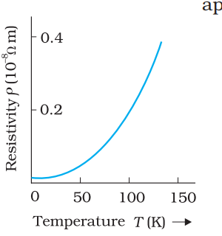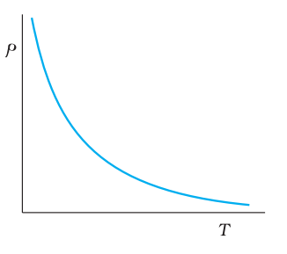  With reason (1.5,1.5) |  |  |  | 3
25. | Diagram with label(1.5)  - Electromagnetic waves with wavelength  - λ1 -gamma  - λ2-xrays  - λ3 -UV
26. | a) Identify the materials A-ferro and B.-para(1/2,1/2)  (b) Identify the material having negative susceptibility-diamagnetic, Copper or any diamagnetic element (1/2,1/2)  c) independent of temperature |  |  |  | 3
27. | a)  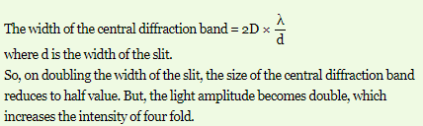(1 +1/2 for reason)
- Formula for resultant intensity(1/2)
Ir=K/4(1/2 mk)
28. | State Bohrs postulate (1 mk)  Proof (2 mk)
 | SECTION -D Case Study Based Questions
29.
(i) | (d) 4B_{o}L² Wb.
(ii) | c)Lenz
(iii) | d)energy
(iv) | d)zero
 | OR
(iv) | b)
30.
(i) | d) violet
(ii) | b)i=e
(iii) | d)All the above
(iv) | - 30
 | OR
(iv) | b) 45°
 | SECTION -E
31. | a) State Gauss’s law in electrostatics. 1/2  Diagram 1  proof.2 1/2 |  |  |  | 5
 | b)graph(1)
 | OR
 | - Diagram(1)  Proof(3) |  |  |  | 5
 | b)180(1)
32 . | - Principle(1)  Proof(2)
- How can a moving coil galvanometer by converted in to an ammeter? (S in parallel to G or diagram (1)
- Torque=BINA(1/2)
Torque for circular loop is greater(1/2mk)
 | OR
- Statement (1)
- Vector form(1)
 | - 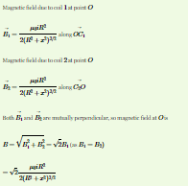 |  |  | 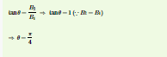 | 2+1
33. | a) diagram of an astronomical telescope in normal adjustment(2 mk)  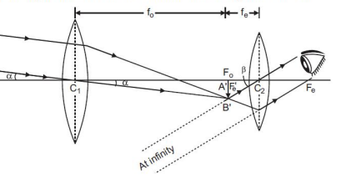
b)M =fo/fe=144/6=24 (1)
L=fo+fe=130cm(1)
c)Objective-L1 (1/2)
Eye piece-L 3(1/2)
 | OR
- Diagram(1mk)
proof(3)
- P red < P violet (1/2) formula (1/2)
 | 
  

